**FIT 3077 SPRINT 1**

**DELIVERABLES**

Team Name: **U-knownZero**

Team Members:

Lee Eng Jie (33002703)

Yeoh Ming Wei (32205449)

Yew Yee Perng (32205481)

Tutorial: 01

# Table of Contents

**Table of Contents 2**

Team Information 3

User Stories 5

Domain Model 7

Basic UI Design 9

**References 16**

**Contribution Log 16**

# Team Information

**Team name: U-knownZero**

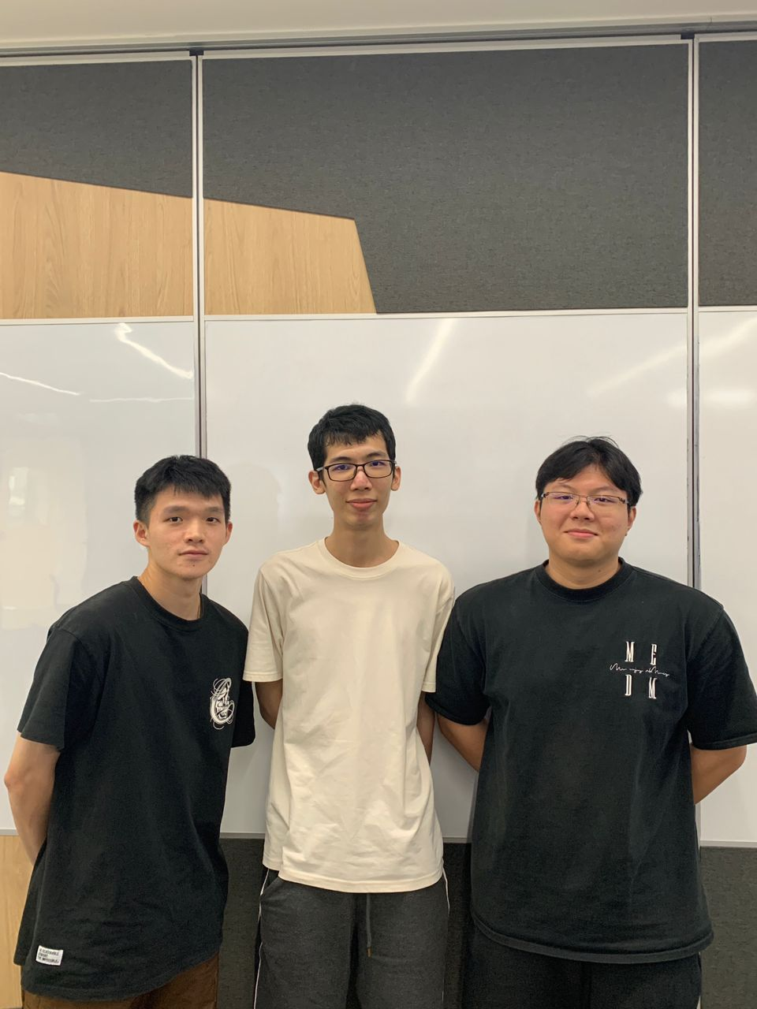

***From Left To Right:*** *Lee Eng Jie, Yeoh Ming Wei, Yew Yee Perng*

**Team membership:**

|  | **Name** | **Phone no.** | **Technical & Professional Strength** | **Fun fact** |
| --- | --- | --- | --- | --- |
| 1) | Lee Eng Jie | +6016-7946165 | * Few programming languages * Communication | I love basketball |
| 2) | Yeoh Ming Wei | +6018-9510388 | * Project management * Trustworthiness | I’m an arcade enjoyer |
| 3) | Yew Yee Perng | +6011-10770719 | * Analytical and critical thinking abilities * Good collaborative skills | I love gym |

**Team Schedule:**

Since most of our team members are busy during afternoons, we prefer to conduct online meetings during the night. During our first team discussion, we decided that the preferred day to conduct meetings is during any free day that all team members do not have any classes and is available through an online platform named Zoom. Our target is to conduct meetings at least twice a week for status updates and to ensure that everyone does work progressively instead of procrastinating to avoid any last minute work. In any special case such as issues in our project, emergency meetings are held as soon as possible to discuss an effective solution to the issue. During the meeting, we will start to work on our project until our target requirements are met.

We will begin by understanding the scope of our project, including tasks and responsibilities that need to be managed. Once the workload is identified, we will begin to prioritise the tasks based on the importance and urgency of the task’s dateline given by us. We will then assign tasks to each member based on their skills and availability. Lastly, regular meetings will be conducted to address concerns and maintain optimal team output.

As of this sprint, our work has been evenly distributed as everyone took part to work on all tasks together. All answers and information on the document has been discussed and decided by all the members of the team.

**Technology Stack and Justification:**

To begin with, we were given two programming languages, python and java to choose on which to use in our project. For the APIs, we did research on both python and java APIs. For python, we looked into several APIs such as pyKyra and pyGame. Pykyra is the most recent and fastest python game creation platform whereas pyGame is the most popular game development framework in python language. On the other hand, libGDX and LWJGL are the current popular java game development frameworks available for use which could serve as an option for our project. Our team is planning to use one of the above APIs for our current project. Although our team has no experience on all of the APIs mentioned above, we have basic fundamental knowledge on both programming languages enough to support our research on the APIs mentioned above and we are confident in producing an executable project with one of the APIs mentioned above for the upcoming sprints.

After deep consideration and discussion among the team, we decided to use Java as

our programming language as we felt it would work better adhering to the OOP principles taught in class and libGDX as our API as it does well in accessing low level functionality whenever higher level abstraction does not suffice .

# User Stories

1. As a player, I want clear and concise instructions provided in the game so that I understand the rules and mechanics of the game and am able to play it smoothly.
2. As a player, I want a user-friendly general user interface with clear and visible buttons to enhance my user experience in the game.

3) As a dragon, I must move back n steps when I get caught by n pirate dragons so that I can save myself from n pirate dragons.

4) As a dragon, I want to have a scientific name so that I can identify my identity.

5) As a dragon, I want to flip a card the same as me so that I can move n steps based on the card number.

6) As a game judge, I want to know the specific player age so that I can determine which player starts first.

7) As a game judge, I must make sure that the player can only flip a close chit card so that the player cannot flip open chit cards again during extra turns.

8) As a dragon, I want to have a chance to flip a card that is different from my kind so that I couldn’t move forward.

9) As a dragon, I would like to reach my cave with the exact number of moves so that I would not need to go another round again.

10) As a dragon, I must not move to the square that is occupied so that I do not interfere with another animal that is in front of me.

11) As a player, I want a feedback system to provide suggestions so that I can play a continuous improvement game.

12) As a dragon, I must move in a clockwise direction unless flipping on the dragon pirate card so that the game can run smoothly.

13) As a player, I want to have different configurations for my volcano cards so that I can have different layouts every game.

14) As a dragon, I would like to have immunity to the dragon pirate chit card while inside the cave so that I would not be affected by the punishment brought by flipping the dragon pirate chit card.

15) As a dragon, I can have extra steps when I’m landed at the volcano card that is the same as me so that I can progress the area more.

16) As a player, I want to start a new game when the game is over so that I do not need to restart the application.

17) As a game judge, I must make sure that the chit card is flipped as hidden after the turn ends so that the player cannot recognize the chit card.

18) As a game developer, I would like to have an even amount of chit cards of each animal kind so that the game would be fair.

19) As a player, I would like the player turns to be rotated in a clockwise direction so that we can ensure the consistency of the order in the game.

20) As a dragon, I must flip the animal that is the same as me so that I can move out from the cave and move a step to the volcano card in front of me.

**Extension:**

21) As a player, I want to have a time limit to perform a move so as to increase the difficulty of the game.

22) As a player, I want engaging sound effects so that I can have an immersive gaming atmosphere.

23) As a player, I want to be able to increase the size of the game area so that I can see the game clearly.

24) As a player, I want to have a different theme of the board so that I can find a suitable theme that I like.

25) As a game developer, I want to add more animals to increase the players and at the same time increase the difficulty of the game.

# Domain Model

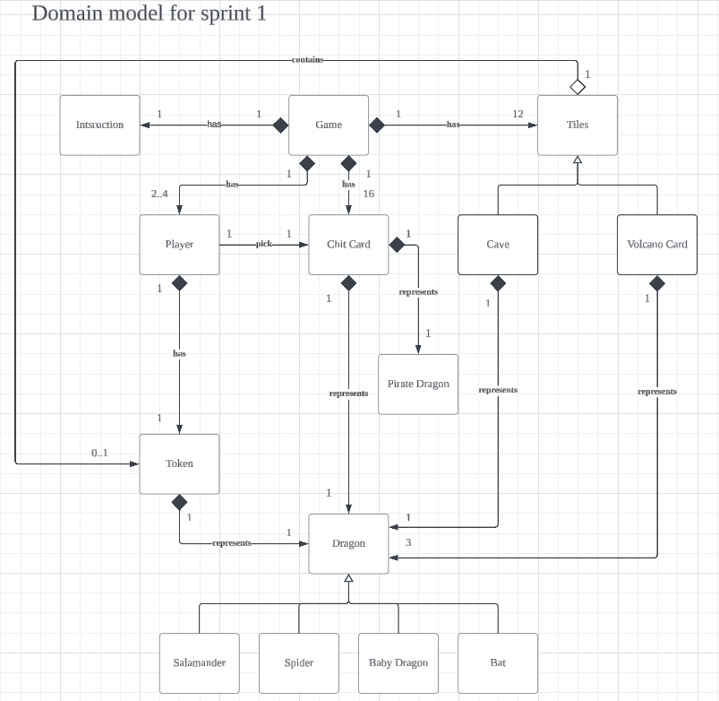

**Justification for Domain Model:**

In our domain model, Game entity is the main entity as we are reflecting Fiery Dragon game in our project. In the game, we have a few entities that must be included in the game such as the instruction manual, chit card, player, and tiles, which means that the game can only be played with these objects. Hence, the relationship between the game and these entities are composition such that the game has 1 instruction, 16 chit cards and 12 tiles (4 caves and 8 volcano cards).

Starting from the player, we have a composition between player entity and token entity that shows that one player can only have one token. Since the token represents a dragon, there will also be a composition relationship between a token and a dragon. In short, a player must have a token that represents one of the dragons.

In the game, we also have chit cards that represent dragons to move the player token based on the number of dragons on the chit card with the corresponding dragon. Since chit cards must represent a dragon to make a move, chit cards will have a composition relationship with the dragon entity. A chit card can only represent one dragon in a relationship arrow. Besides that, the chit cards also contain 4 pirate dragon cards that will force the player’s token to move backwards based on the number of pirate dragons displayed at the chit card. The relationship still remains the same which is one on one between chit card and pirate dragon.

The tiles will be the game board that consist of volcano cards and caves that are considered as tiles. So, the Volcano Card and Cave entities will be generalised from the tile entity. In addition, each cave can represent 1 dragon. So, the cave has a composition relationship with dragons which is a one to one relationship. However, each volcano card contains three dragons, hence volcano card entity and dragon entity can have one to three composition relationship with dragon entity.

Moving on to the dragon entity, we have 4 different types of actors which are salamander, spider, bat and baby dragon. Since these actors are dragon types, these dragons can be generalised from the dragon entity.

# Basic UI Design

**HOME PAGE**

* **i represents instruction set for player**
* **Sound UI**
* **Feedback UI**

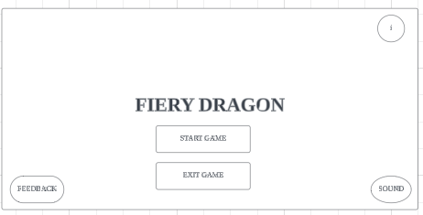

* **After clicking on start game, this interface would allow the user to select one of the three options.**

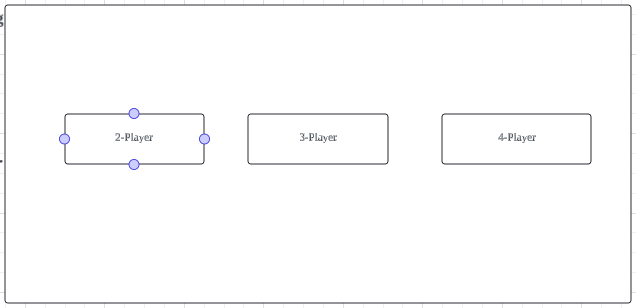

* **Players are able to choose their board configuration**
* **Given 8 volcano cards, players can choose the arrangement.**

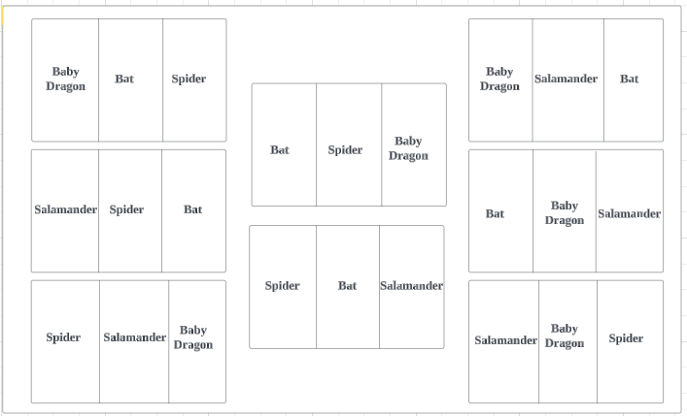

* **After selecting on 4 player and choosing on the board configuration**
* **Set up of a Game start scenario**
* **Uncovering dragon cards of various types**
* **Uncovering of volcano cards**
* **Time limit for each player's turn**
* **The game will be played in a clockwise direction, player 1 is the youngest, he will start first, and followed by player 2, 3 and 4.**

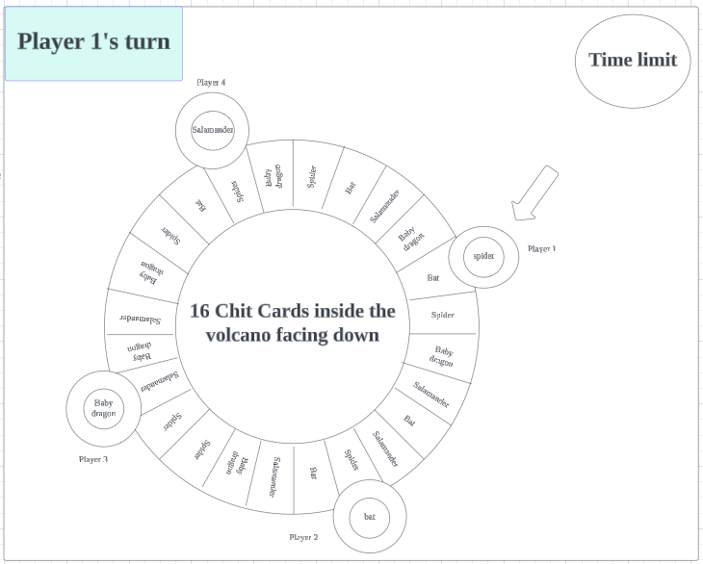

* **Moving of a dragon token forward eg. Spider token**
* **During Player 1 turns, initially his dragon is inside the cave, he flipped a 2 spider chit card, this will allow his token to move 2 steps, which results his final token(shown in red) to be at spider volcano.**
* **Now, player 1 can choose to uncover another chit card with 2 spider card face up or ends his turn.**
* **After player 1's turn, cover up all chit cards.**

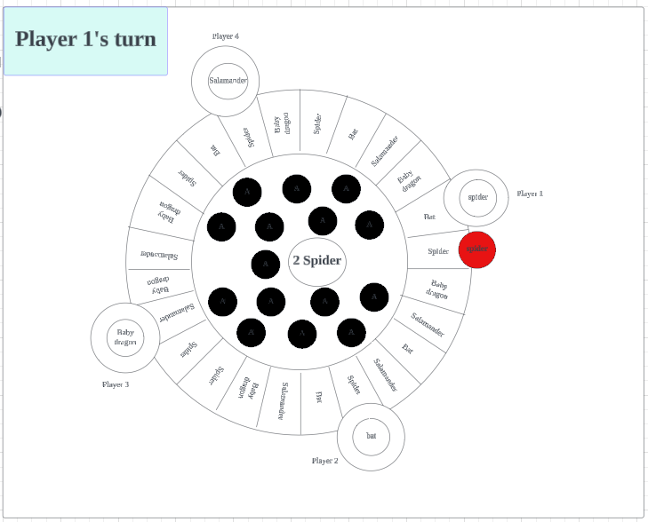

* **Moving of a dragon token backward eg. Spider token**
* **During Player 1 turns, initially his dragon(shown in white) is at bat volcano, he flipped a 1 pirate dragon chit card, this will cause his token to move 1 step backward, which results his final token(shown in red) to be at salamander volcano.**
* **Now, player 1 can choose to uncover another chit card with 1 Pirate Dragon card face up or end this turn.**

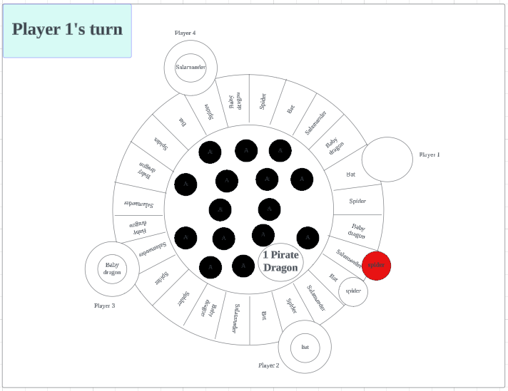

* **During player 1's turn, he uncover a 2 bat chit card, he will move his dragon token 2 steps forward, which will result in a baby dragon volcano.**
* **Since baby dragon volcano is occupied by another dragon token, player 1's token(shown in red) will remain in the initial cave.**
* **Player 1's will not be able to uncover another chit card and his turn will be over.**

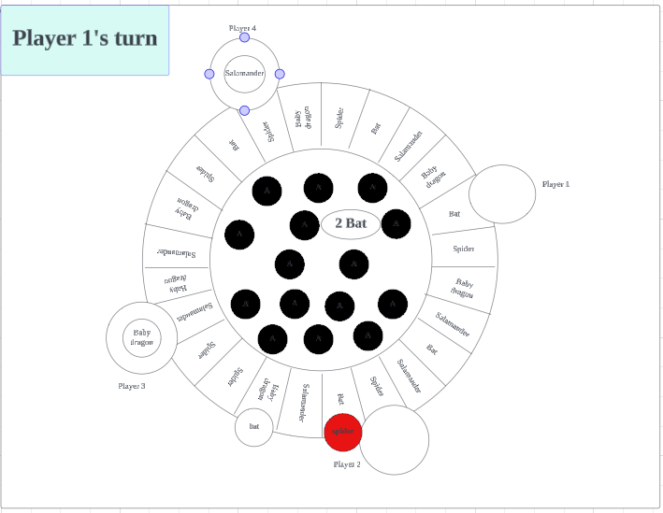

* **Player 1 is in a winning situation**
* **He uncovers a 3 bat chit card during his turn, which allows his dragon to move 3 steps forward since his dragon(shown in white) is at a bat cave.**
* **Player 1 will win the game as his dragon returns back to the cave with exact number moves.**

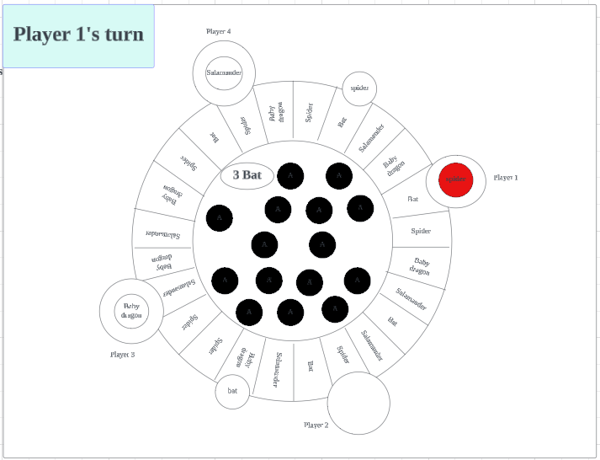

# 

# 

# References

<https://www.reddit.com/r/gamedev/comments/9i8elm/best_framework_to_go_with_for_java_2d_game/>

<https://medium.com/unikaksha/top-6-python-framework-for-game-development-3108c850522c>

<https://cdn.haba.de/medias/manual/4498-drachenstark-spielanleitung-6s.pdf>

# Contribution Log

